Targeted MDISK Access

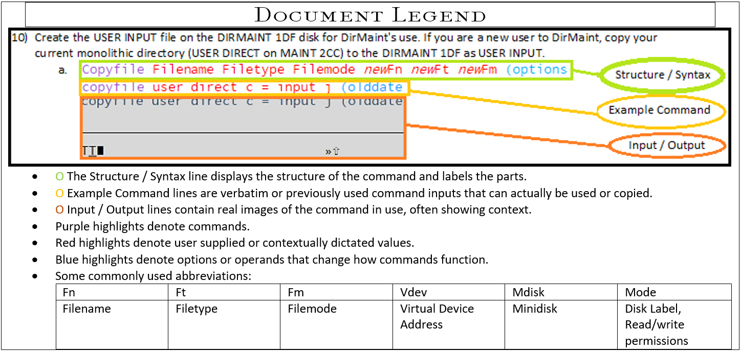  
Identify the MDISK file location on the DASD of the target system. Need to answer: What DASD is it on, what MDISK and what cylinder range of that MDISK? This information can be found using an mdisk map from dirm (DIRMAP). Once you have this information the range can be defined and subsequently assigned a filemode and accessed. In this example, the System Config file of a second level installation is being accessed from first level.

1. Request an MDISK map from DIRM.
   1. Dirm Dirmap  
      Dirm Dirmap  
      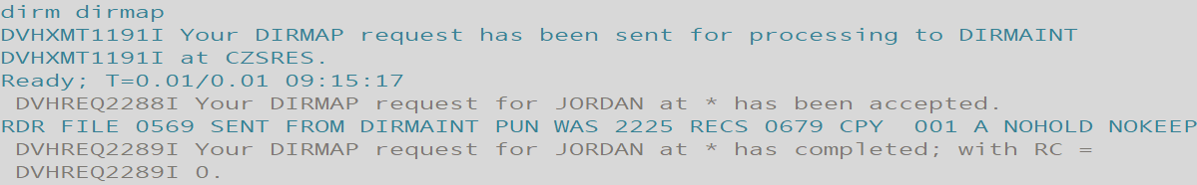
   2. Receive filenumber (option  
      Receive 569 (replace  
      
      1. Use the replace option if there is already a Dirmap present on the disk being saved to.
   3. Xedit filename filetype filemode  
      xedit user mdiskmap  
      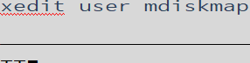
   4. /searchcharacters  
      /pmaint  
      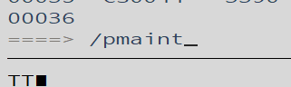
      1. This searches and located the Pmaint user and brings the current line area to Pmaint’s entries.  
           
         
      2. Take note of the cylinders written on for the MDISK containing the file you wish to edit.
      3. Note the VOLID as well. These are the values needed for this procedure.
      4. In this example, System Config is located on CZSCM1 DASD, PMAINT’s 0CF0 MDISK, located in the 1-120 cylinder range. Remember to use the DASD VOLID of the device you wish to access and not your example if using another system’s map.
2. Attach the DASD device holding the files you wish to access to the system if not already attached, to be accessible (mounted.)
   1. Query operand  
      q dasd  
      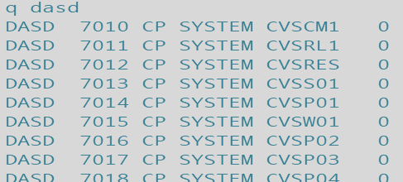
   2. Attach vdev prefix user  
      att 704a-704f to system  
      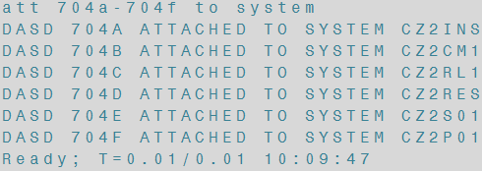
      1. If the DASD are attached elsewhere, make sure they are not in use then use detach to detach them from the target before attaching.  
         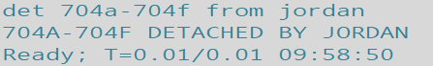
3. Define the range of cylinders found with the Dirmap.
   1. Define mdisk vdev start length volser  
      define mdisk cf0 1 120 czscm1  
      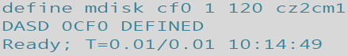
4. Assign a filemode and access the range.
   1. Access vdev filemode  
      acc cf0 h  
      
5. List the files to be edited using filelist or dirlist.
   1. Filelist filename filetype filemode  
      filel \* \* h  
      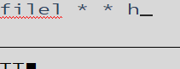
      1. \* Asterisk are wildcards.

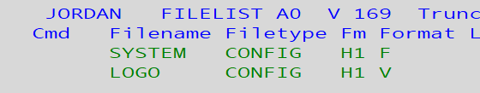

* 1. Dirlist (device  
     Dirlist (mdisk  
     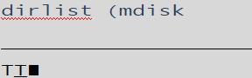  
     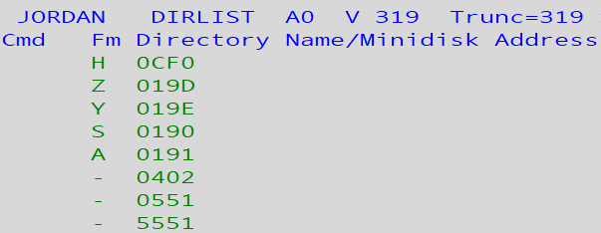

1. Congrats you’re now viewing files from another system!